**GANPAT UNIVERSITY**

**U. V. PATEL COLLEGE OF ENGINEERING**

**B.Tech CE/IT Semester IV**

**2CEIT404: Python Programming**

**Practical-7: File Operations**

1. Write a Python program to read content from a file and display the word with maximum length.

INPUT:

print(21012011074)

f1=open("C:/Users/gurup/OneDrive/Desktop/python/guru.txt","r")

x=f1.read()

l1=x.split()

l=len(max(l1))

for i in l1:

if len(i)==l:

print(i)

f1.close

OUTPUT:

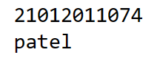

1. Write a Python program to combine each line from first file with the corresponding line in second file.

INPUT:

print(21012011074)

with open("C:/Users/gurup/OneDrive/Desktop/python/guru.txt","r") as f1:

with open("C:/Users/gurup/OneDrive/Desktop/python/guru1.txt","r") as f2:

x=f1.readlines()

y=f2.readlines()

m=min(len(x),len(y))

for i in range(m):

z=x[i].strip()+" "+y[i].strip()

print(z)

f1.close

f2.close

OUTPUT:

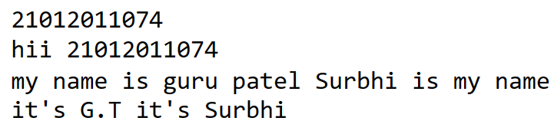

1. Write a Python program to read first n lines of a file.

INPUT:

print(21012011074)

with open("C:/Users/gurup/OneDrive/Desktop/python/guru1.txt","r") as f1:

x=f1.read()

print(x)

f1.close

OUTPUT:

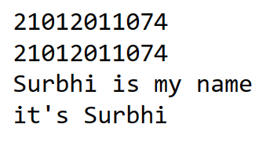

1. Write a Python program to write students information into csv file and read that details.

INPUT:

print(21012011074)

import csv

with open("C:/Users/gurup/OneDrive/Desktop/python/p7_4.csv","w",newline='') as file:

writer=csv.writer(file)

writer.writerow(["SN","NAME","BRANCH"])

writer.writerow([1,'Guru','CE'])

writer.writerow([2,'Surbhi','MBBS'])

writer.writerow([3,'Rushi','IT'])

writer.writerow([4,'Vinit','CE'])

writer.writerow([5,'Jinal','MBBS'])

file.close

OUTPUT:

